Assignment-1
Name | Roll No | Discipline | Marks | Grade
Anil | 1 | CSE | 86 | A
Rathin | 2 | CSE | 67 | B
Sikha | 3 | ECE | 54 | C
Shyamal | 4 | ECE | 45 | D
Paresh | 5 | ME | 49 | D
Trisha | 6 | ME | 64 | B
Rina | 7 | CSE | 54 | C
Anik | 8 | ECE | 54 | C

- Find a list of those students who have acquired more than 50 marks?
- Find name and roll number of those students who have acquired more than 50 marks?
- Find a list of distinct discipline of Students?
- Find name and roll-no of those students who are in CSE discipline?
- List name of students whose marks lies between 60 and 70 (including)?
- Find out the details of students whose disciplines are ECE and ME?
- List name and roll-no of students in descending order of marks?
- Find a list of students name and Roll number whose Marks are NULL?
- List name and Roll number of those students who’s Marks are not NULL?
- Find a list of names and marks from the student database remaining of the attribute as "Student's Name" and "Marks Obtained" respectively?
- Find the entire Student's names and Roll-no whose name starts with S?
- Find all students’ name and Roll-no whose name matches with "ANI_"?
- Find out the total marks of all the students?
- Find out the average marks of all the students?
- Find out the maximum marks obtained by a student?
- Find out the minimum marks obtained by a student?
- Find out the number of students who have got 50 marks or more?
- Find the name, Roll-no, Marks of the students grouped by MARKS?
- Find Name, Roll-No, Marks of students whose marks are more than 50 grouped by Marks?

ANSWER
TO CREATE THE STUDENT TABLE
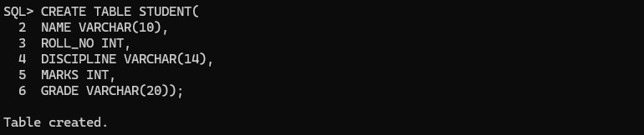

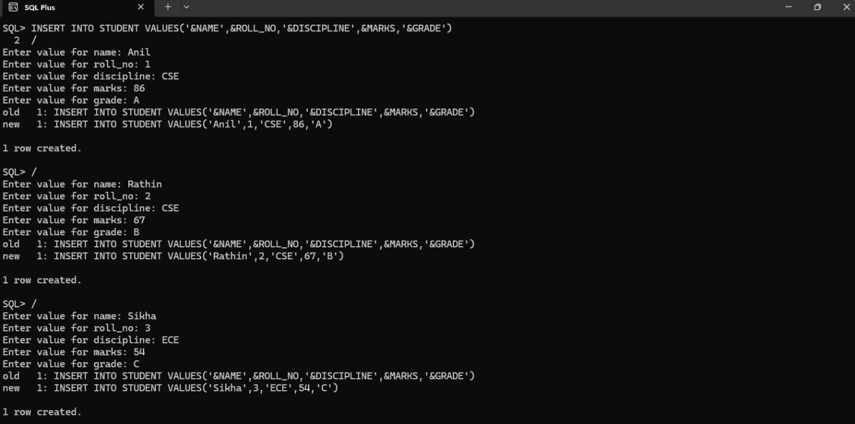
INSERTING GIVEN DATA IN THE STUDENT TABLE

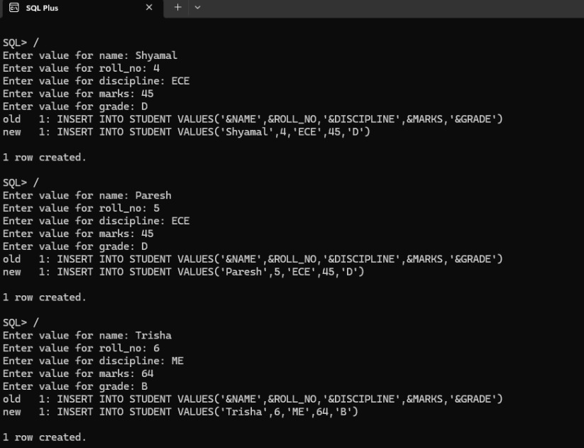
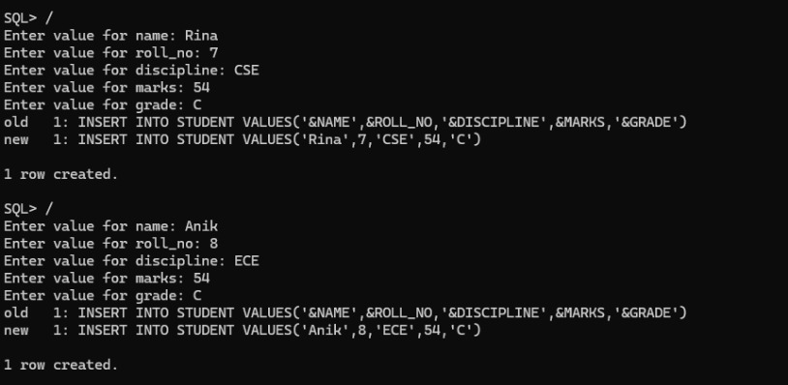

TO SHOW THE INSERTED DATA IN THE STUDENT TABLE

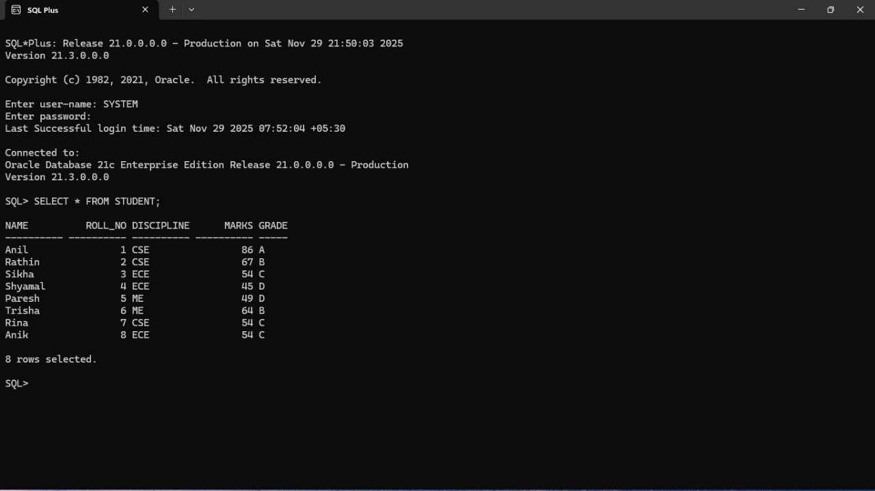

Find a list of those students who have acquired more than 50 marks?

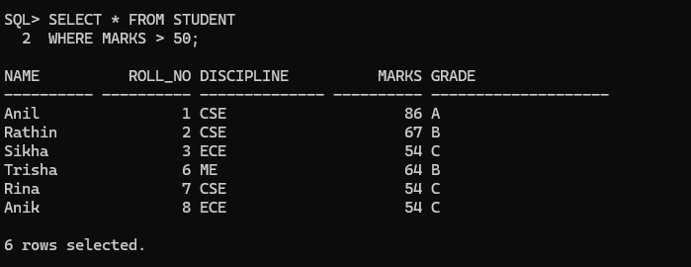

Find name and roll number of those students who have acquired more than 50 marks?

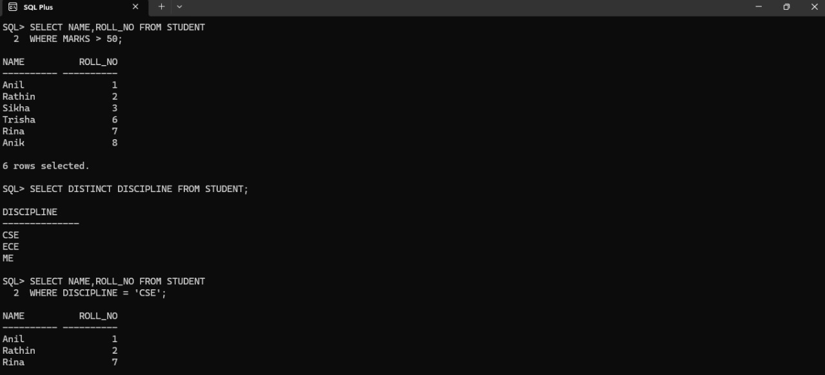

Find a list of distinct discipline of Students?

Find name and roll-no of those students who are in CSE discipline?

List name of students whose marks lies between 60 and 70 (including)?

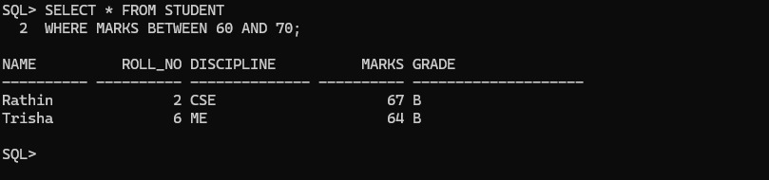

Find out the details of students whose disciplines are ECE and ME?

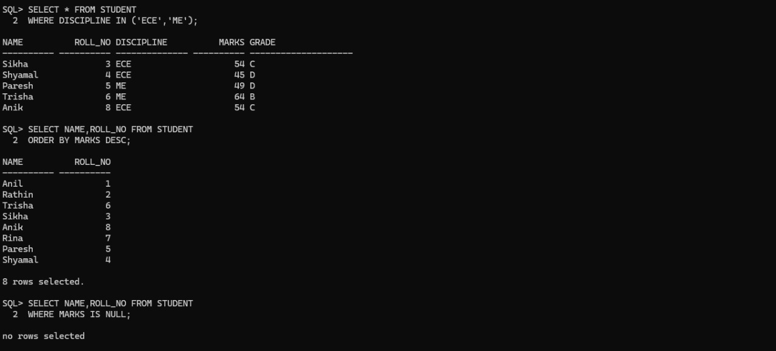

List name and roll-no of students in descending order of marks?

Find a list of students name and Roll number whose Marks are NULL?

List name and Roll number of those students who’s Marks are not NULL?

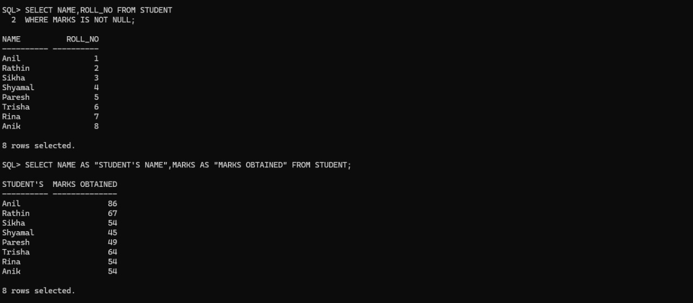

Find a list of names and marks from the student database remaining of the attribute as "Student's Name" and "Marks Obtained" respectively?

Find the entire Student's names and Roll-no whose name starts with S?

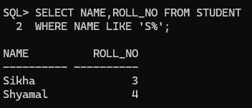

Find all students’ name and Roll-no whose name matches with "ANI_"?

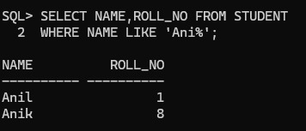

Find out the total marks of all the students?
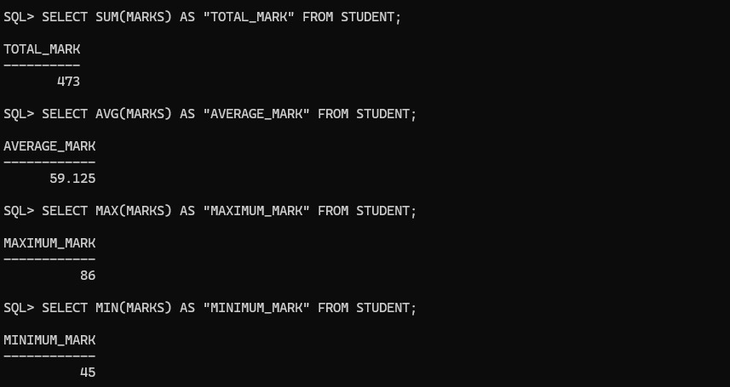

Find out the average marks of all the students?

Find out the maximum marks obtained by a student?

Find out the minimum marks obtained by a student?

Find out the number of students who have got 50 marks or more?

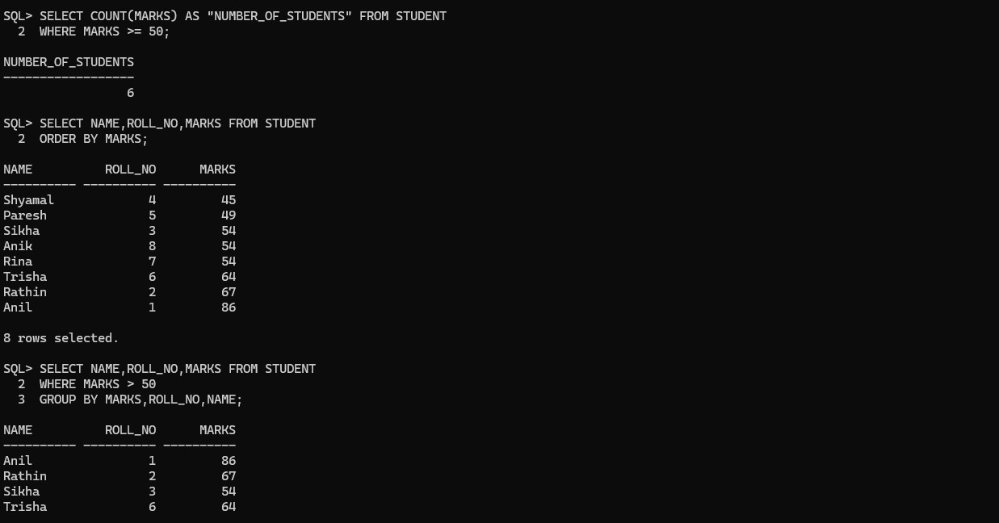

Find the name, Roll-no, Marks of the students grouped by MARKS?

Find Name, Roll-No, Marks of students whose marks are more than 50 grouped by Marks?

